1. Usecase diagram

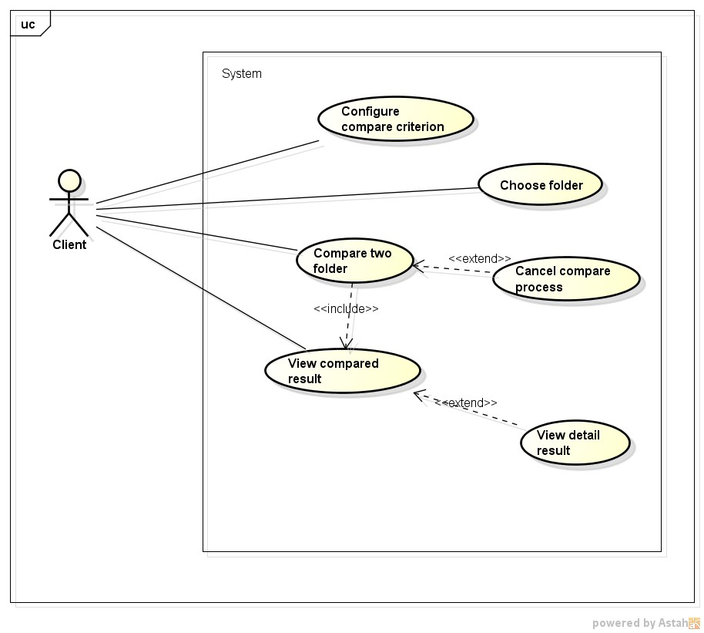

|  |  |  |  |
| --- | --- | --- | --- |
| Use Case ID: | NFD001 | | |
| Use Case Name: | Configure compare criterion | | |
| Created By: | KhanhKC | Last Updated By: | KhanhKC |
| Date Created: | 10/3/2015 | Date Last Updated: | 26/03/2015 |
| Actor: | Client | | |
| Description: | Client modify criterion which will be used in compare the process. | | |
| Preconditions: | Client on main screen | | |
| Post - conditions: | The client setting has been saved and it is apply immediately  in the next compare process | | |
| Priority: | Normal | | |
| Frequency of Use: | Sometime | | |
| Normal Course of Events: | 1. Client request to change criterion.  2. System enable change criterion slider.  3. Client use slider to change criterion.  4. Client request to save setting.  5. System save setting.  6. System disable change criterion slider. | | |
| Alternative Courses: |  | | |
| Exceptions: |  | | |
| Includes: | N/A | | |
| Specical Requirements: | N/A | | |
| Assumptions: | N/A | | |
| Notes and Issues: | N/A | | |

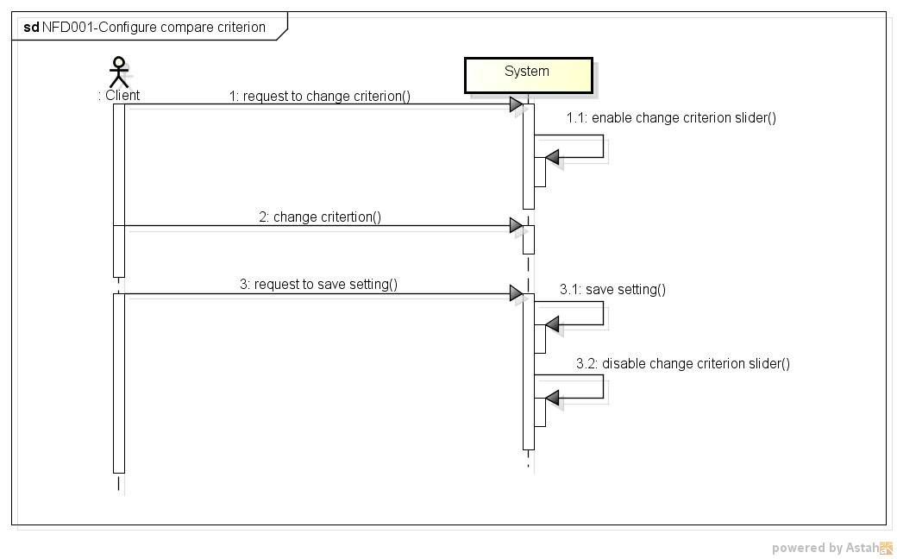

|  |  |  |  |
| --- | --- | --- | --- |
| Use Case ID: | NFD002 | | |
| Use Case Name: | Choose folder | | |
| Created By: | NhungNTH | Last Updated By: | NhungNTH |
| Date Created: | 10/3/2015 | Date Last Updated: | 26/03/2015 |
| Actor: | Client | | |
| Description: | Client chooses two folder which system need comparison. | | |
| Preconditions: | Client is working on the main screen. | | |
| Post - conditions: | Main screen shows absolutely path of folders. | | |
| Priority: | High | | |
| Frequency of Use: | Always | | |
| Normal Course of Events: | 7. Client clicks “Folder 1” and choose folder one.  8. Client clicks “Folder 2” and choose folder two.  9. Main screen will show absolutely path. | | |
| Alternative Courses: | N/A | | |
| Exceptions: | 1. Client choose “ Folder 1 ” ,and choose folder one.  2. Client choose “Folder 2 ” ,and choose folder two. But  folder two identifies with folder 1.  3. System will display an error message: “Please choose two different folders”. | | |
| Includes: | N/A | | |
| Specical Requirements: | N/A | | |
| Assumptions: | N/A | | |
| Notes and Issues: | Client only chooses folder not file. | | |

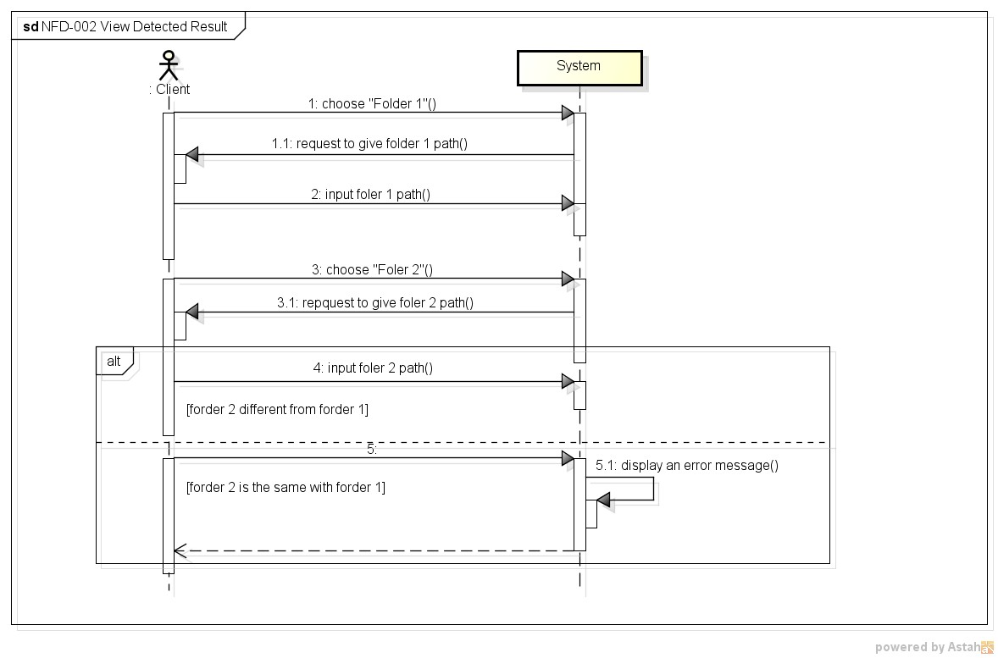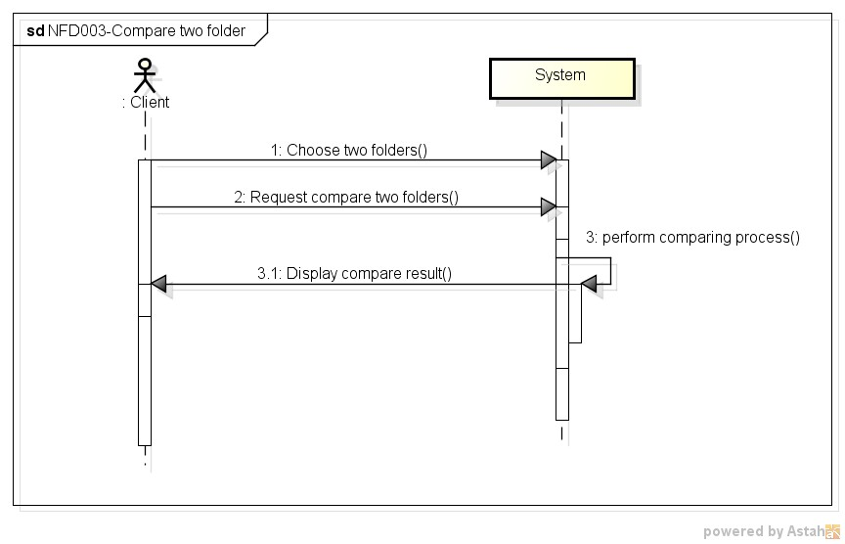

|  |  |  |  |
| --- | --- | --- | --- |
| Use Case ID: | NFD003 | | |
| Use Case Name: | Compare two folder | | |
| Created By: | KhanhKC | Last Updated By: | KhanhKC |
| Date Created: | 10/3/2015 | Date Last Updated: | 26/03/2015 |
| Actor: | Client | | |
| Description: | Client request system to compare all of the files in two  folders and in their sub-folders to determine which one is the newer. | | |
| Preconditions: | Client on main screen | | |
| Post - conditions: | The client setting has been saved and it is apply immediately  in the next compare process | | |
| Priority: | Normal | | |
| Frequency of Use: | Sometime | | |
| Normal Course of Events: | 1. Client choose two folders.  2. Client request compare two folders.  3. System perform comparing process.  4. System display compare result (refer to NFD-005 – view compared result) | | |
| Alternative Courses: |  | | |
| Exceptions: | In case, client choose only on folder, system will show  notification message “”.  In case, client choose 2 empty folder, system will show  notification massage “”.  In case, the compare process raised exception, the system will notify by corresponding error messages | | |
| Includes: | View compared result. | | |
| Specical Requirements: | N/A | | |
| Assumptions: | N/A | | |
| Notes and Issues: | N/A | | |

|  |  |  |  |
| --- | --- | --- | --- |
| Use Case ID: | NFD004 | | |
| Use Case Name: | Cancel compare process | | |
| Created By: | KhanhKC | Last Updated By: | KhanhKC |
| Date Created: | 10/3/2015 | Date Last Updated: | 27/03/2015 |
| Actor: | Client | | |
| Description: | Client want to cancel the compare process when it’s running. | | |
| Preconditions: | Compare process is running | | |
| Post - conditions: | The compare process is stop. | | |
| Priority: | High | | |
| Frequency of Use: | Always | | |
| Normal Course of Events: | 1. Client request to cancel compare process.  2. System show confirm dialog.  3. Client confirm to cancel compare process.  4. System cancel compare process.  5. System back to main screen. | | |
| Alternative Courses: | 1. Client request to cancel compare process.  2. System show confirm dialog.  3. Client confirm to continue compare process.  4. System back to main screen. | | |
| Exceptions: | N/A | | |
| Includes: | N/A | | |
| Specical Requirements: | N/A | | |
| Assumptions: | N/A | | |
| Notes and Issues: | N/A | | |

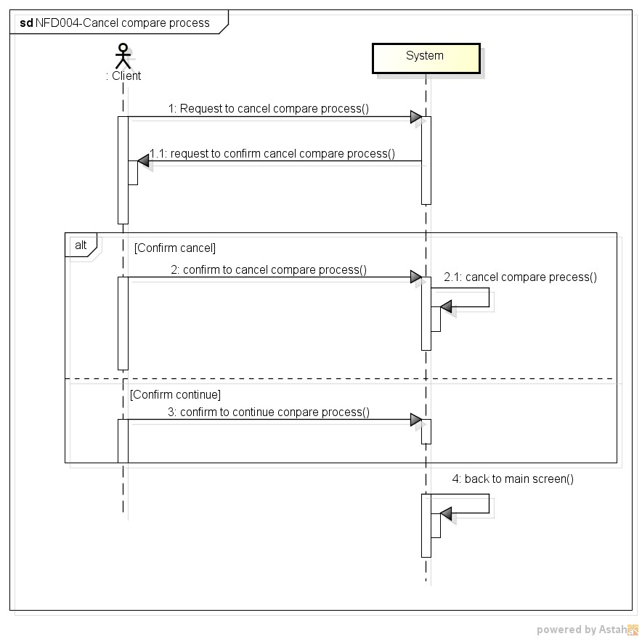

|  |  |  |  |
| --- | --- | --- | --- |
| Use Case ID: | NFD005 | | |
| Use Case Name: | View compared result | | |
| Created By: | NhungNTH | Last Updated By: | NhungNTH |
| Date Created: | 10/3/2015 | Date Last Updated: | 26/3/2015 |
| Actor: | Client | | |
| Description: | System returns result when client clicks “Compare” button. | | |
| Preconditions: | After compare progress step is completed. | | |
| Post - conditions: | The compare result is displayed on the main screen. | | |
| Priority: | High | | |
| Frequency of Use: | Always | | |
| Normal Course of Events: | 1. After compare progress runs with criterions.  2. Client may see the compare result on the main screen. | | |
| Alternative Courses: | N/A | | |
| Exceptions: | N/A | | |
| Includes: | N/A | | |
| Specical Requirements: | N/A | | |
| Assumptions: | N/A | | |
| Notes and Issues: | N/A | | |

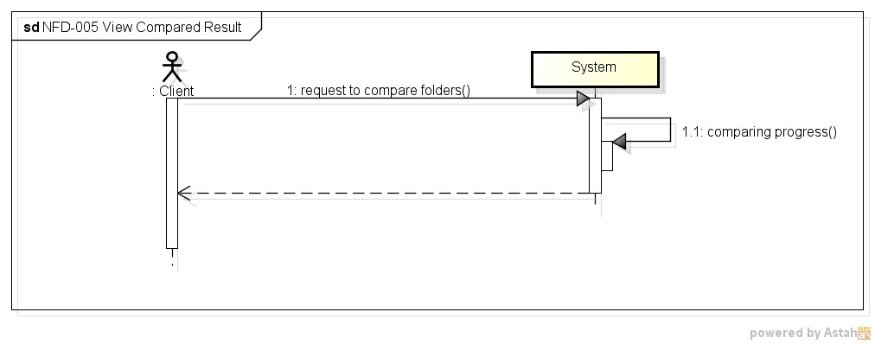

|  |  |  |  |
| --- | --- | --- | --- |
| Use Case ID: | NFD006 | | |
| Use Case Name: | View compared detail | | |
| Created By: | NhungNTH | Last Updated By: | NhungNTH |
| Date Created: | 10/3/2015 | Date Last Updated: | 26/3/2015 |
| Actor: | Client | | |
| Description: | System returns result when client click “Detail” button. | | |
| Preconditions: | After the compare result is displayed. | | |
| Post - conditions: | The detail result is displayed on the main screen. | | |
| Priority: | Normal | | |
| Frequency of Use: | Sometime | | |
| Normal Course of Events: | 1. Client request to view compared detail.  2. System display “compared detail screen”  3. Client may use keyboard or mouse to scroll to see compared detail. | | |
| Alternative Courses: | N/A | | |
| Exceptions: | N/A | | |
| Includes: | N/A | | |
| Specical Requirements: | N/A | | |

Assumptions: N/A Notes and Issues: N/A

